Nischal Shrestha
Coventry University Student ID Number: 17103446
B.Sc. (Hons.) Computing, Softwarica College of IT and E-commerce, Coventry University
ST4005CEM Database System
Giriraj Rawat

- Create table customer with column name customer_id, customer_name, contact_number and country.
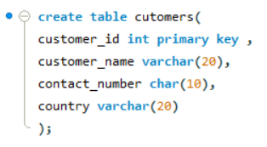

- Create table order with column name order_id, order_date, amount, customer_id (foreign key referencing customer)
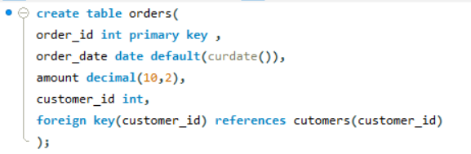

- Insert a sample data minimum 5 records in both table.
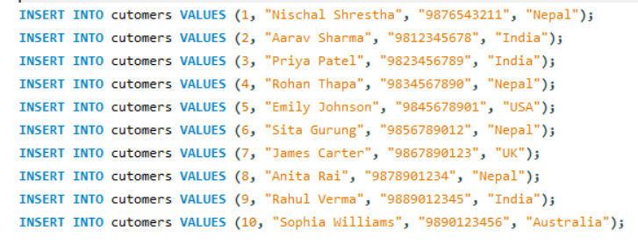
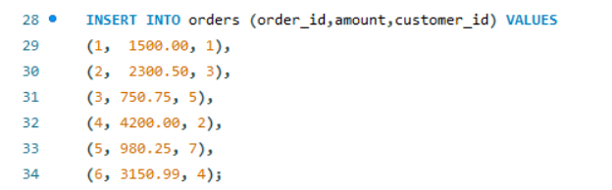

- Update the contact name of customer with ID 3 to 'laxmi prasad'.
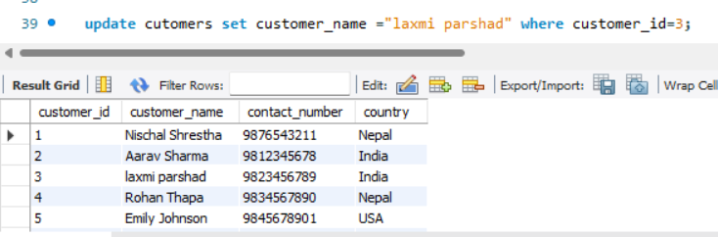

- Update the amount of order with ID 2 to 999.99.

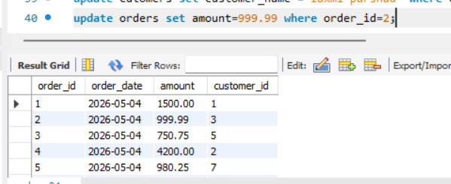

- Delete the customer with customer_id = 5.

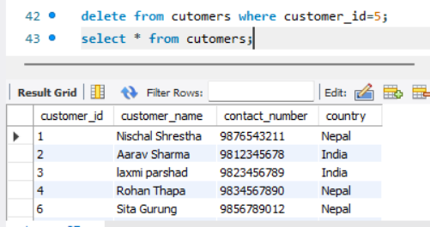

- Delete all orders with an amount less than 1000.
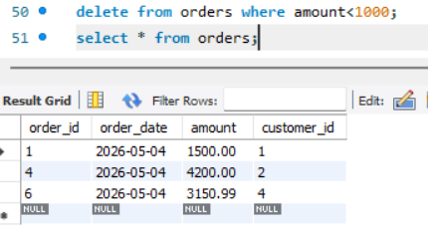
- list all orders sorted by amount in descending order.
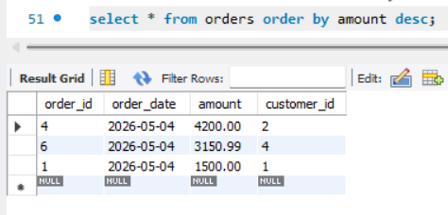
- Display the top 5 most expensive orders.
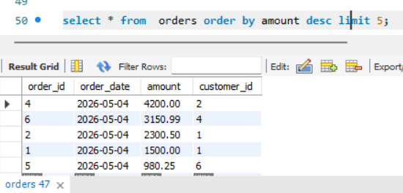

- Show customer names sorted alphabetically.

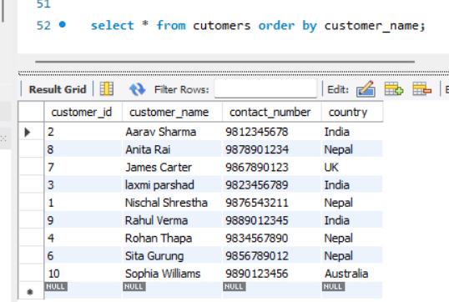

- Get the 3 most recent orders by order_date.

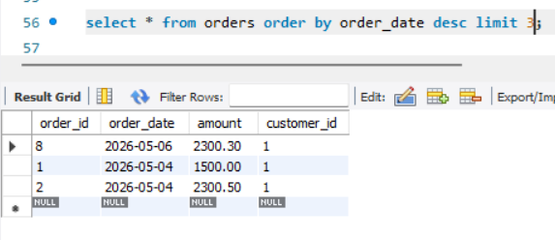

- Retrieve orders, skipping the first 2 records and showing the next 5.

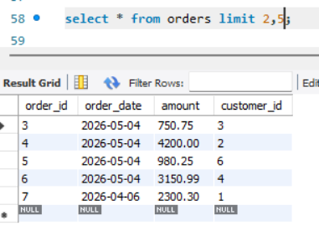
- Find all customers whose name starts with ‘A’.
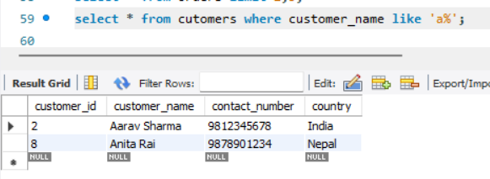

- Find customers whose contact name ends with ‘son’.
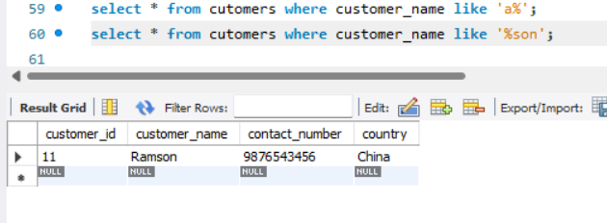
- List orders where amount is between 500 and 1500.

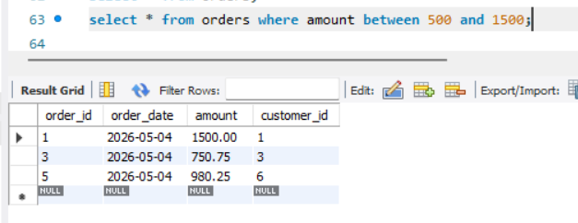

- List customers from countries ‘USA’, ‘Canada’, and ‘UK’ .

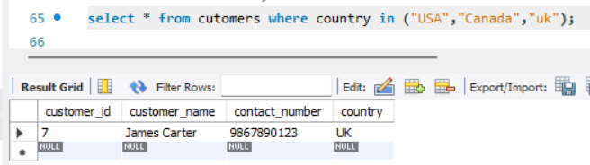

- List all orders with their amount and a status column showing ‘High’ if amount > 1000, otherwise ‘Low’.
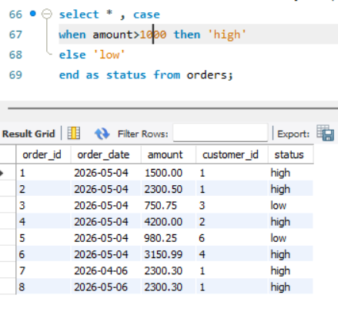
- Demonstrate what happens to orders when a customer is deleted using ON DELETE CASCADE.
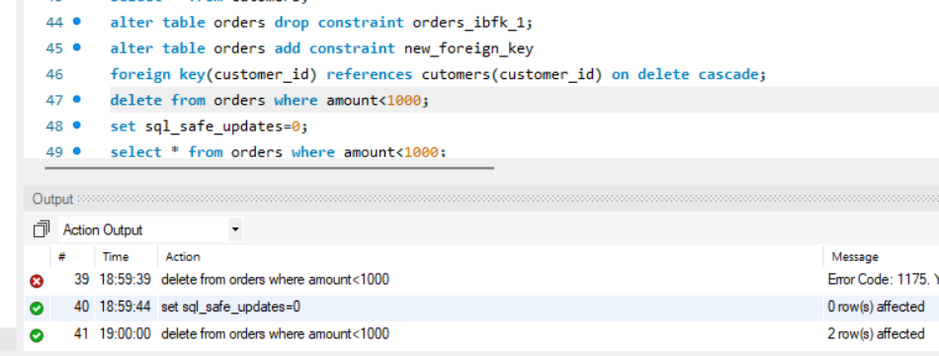

- Demonstrate what happens to orders when a customer is deleted using ON DELETE SET NULL.
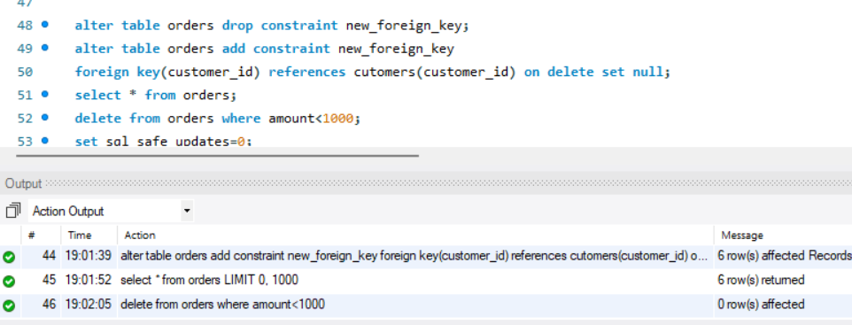

- Write an SQL query to display all customers and their corresponding orders.

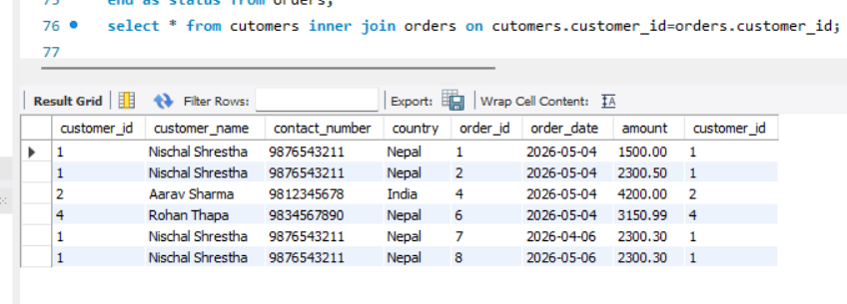

- Write an SQL query to list all customers and their orders, including customers who haven't placed any orders.

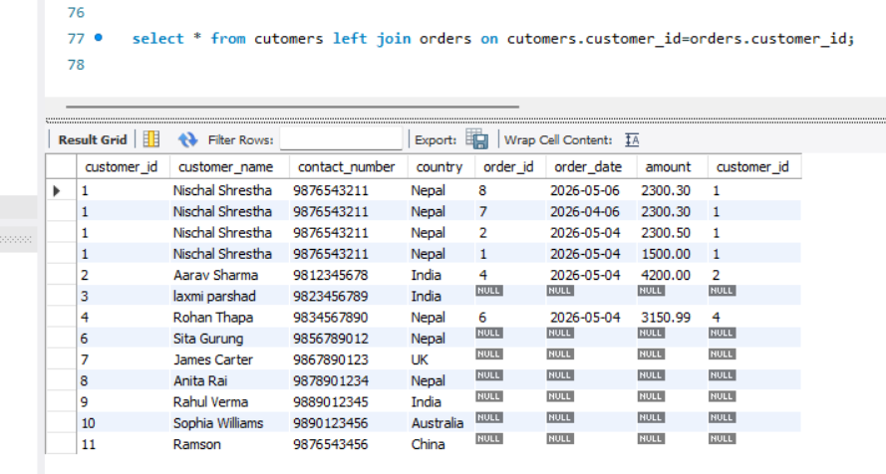

- Write an SQL query to display Order ID, Order Date, and the Customer Name for each order.

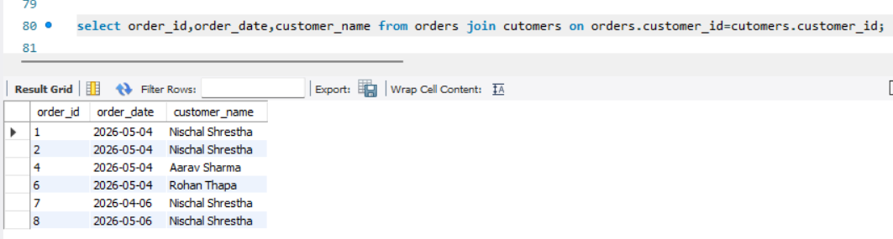

- Display customer names and order amounts sorted by customer name.

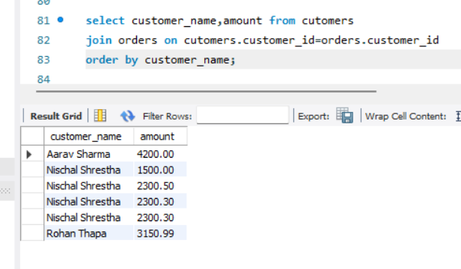
- Use INNER JOIN to list customers who have placed orders with an amount greater than 1000.
